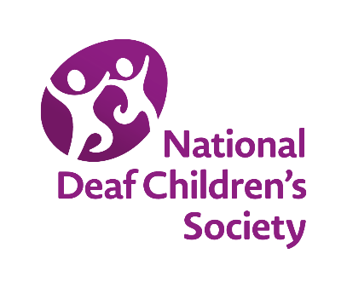
New Committee Information

Group Name:

Committee members
Positions may vary, however we strongly suggest having the roles below in place. You can access Good Committee Guides on the NDCS website www.ndcs.org.uk/localgroups or contact local.groups@ndcs.org.uk for hard copies

Group’s central email contact address: _______________________________________________

Role | Name | Email address | Telephone No. | NDCS Member?
Chair
Treasurer
Secretary

New committee member
Name | Contact number | Email address

Information for new committee members:
The Local Groups Team at NDCS will contact committee members of affiliated local Deaf Children’s Societies with relevant information about support for the group and the committee and to advertise events.
Please confirm you are happy to be contacted in this way by ticking the box here
The consent you give here does not overwrite or relate to your pre-existing membership of NDCS (if you are already a member) but we will link to your NDCS membership account.
If you wish, in the future, to change your contact preferences or to stop receiving information from the Local Groups Team please contact us directly at local.groups@ndcs.org.uk
Please return this form to the email address above.

