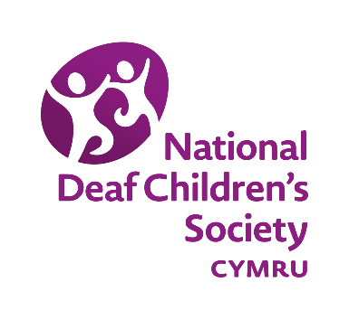
Consultation: the School Organisation Code
National Deaf Children’s Society Cymru
September 2017

About Us
The National Deaf Children’s Society Cymru is the national charity dedicated to creating a world without barriers for deaf children and young people.
We represent the interests and campaign for the rights of all deaf children and young people from birth until they reach independence.
In referring to deaf, we refer to all levels of hearing loss including mild to profound, unilateral and temporary.
Response
The National Deaf Children’s Society Cymru is keen to ensure that in reorganising schools, particular attention is paid to provision for pupils with Additional Learning Needs. We suggest that the references to SEN within the Code could be strengthened in the following ways:
- We urge that consideration of any existing specialist provision for pupils with Additional Learning Needs should also be included within section “1.6 Other General factors”. While this section highlights equality issues, we feel it would be beneficial to explicitly refer to SEN provision.
- We would suggest that the sections on specific factors to consider in proposals to reorganise nursery classes and sixth forms should also consider ALN support.
- Section 1.14 places great emphasis on promoting an inclusive approach for pupils with SEN. Although mainstream provision may be appropriate for many deaf children and young people, it will not be appropriate for all. There will be some deaf children and young people who will benefit from attending a specialist school/ resource base for the deaf. We would, therefore, suggest that the emphasis is placed on ensuring that pupils with SEN have viable choices in accessing specialist support and/or inclusive mainstream provision.
- Due to the low incidence nature of deafness, schools with specialist resource bases are often accessed by neighbouring local authorities. It is, therefore, vital that the impact of proposals regarding SEN provision is considered outside of the local authority boundaries. While we appreciate that section 1.14 of the Code references this, we would recommend that greater emphasis is placed on this point.
- Page 17 recommends that consideration is given to whether there is surplus SEN provision within an area. The National Deaf Children’s Society Cymru would urge that this recommendation is taken with caution. Due to the nature of many low incidence SEN needs, pupil numbers can fluctuate regularly. It is also important to note that it can be difficult to recruit support staff with an appropriate skill set and knowledge of low incidence SEN. As such, it is imperative that when reviewing surplus SEN provision, consideration must be given to the longer term requirements for a specialist service.
- Annex B: The template letter highlights the need to outline SEN arrangements where the reorganisation involves a special school, but it should also do this where a school has had a specialist resource base.
- We recommend that the Code highlights the importance of providing consultation documents in accessible formats.
- We would also recommend that, where a proposal affects a specialist resource base, efforts should be made to seek the views of the SEN pupils who access the base.
- Page 70. The National Deaf Children’s Society recommends that, in cases where SEN provision is affected, the local decision-making committee includes an independent expert with knowledge of the relevant SEN.
- The former 2009 version of the Code emphasised that “consideration should be given to how changes to schools are likely to impact on all the other services provided by the authority for pupils with disabilities and/or SEN. Any change should not be detrimental to the standard of these services.” The National Deaf Children’s Society Cymru urges the Welsh Government to repeat this emphasis in the new Code.
- The former 2009 version of the Code also highlighted key points to be taken into consideration when making a decision about a proposal relating to SEN provision. This included the impact of the proposal on SEN provision both inside and outside the local authority boundaries. The Code also recommended that expert advice could be sought when making a decision on an SEN proposal. Furthermore, it urged that decision makers should assess whether the reorganisation proposal fits within a clear strategic framework for meeting the full range of SEN in the local authority. The National Deaf Children’s Society Cymru would strongly recommend that these points are placed in the new version of the Code
Contact
If you would like any further information in relation to this response, please do not hesitate to contact us at Campaigns.Wales@ndcs.org.uk.

