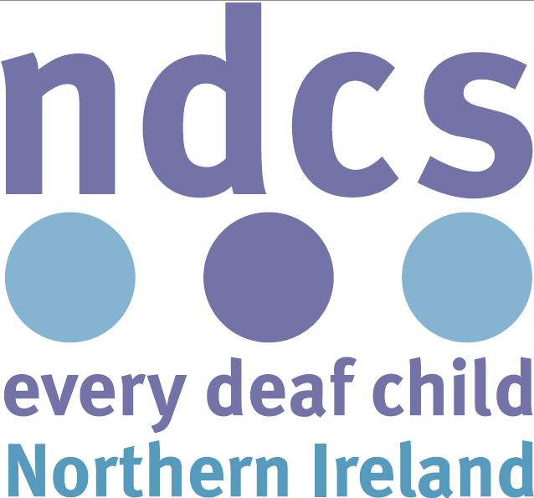

Response to

Executive Department Draft

Framework Programme for

Government

Contact:
The National Deaf Children’s Society
38-42 Hill Street
Belfast
BT1 2LB

Tel: 02890704119
Email: Janice.watkins@ndcs.org.uk

Introduction:

The National Deaf Children’s Society (NDCS) is the national charity dedicated to creating a world without barriers for deaf children and young people. We represent the interests and campaign for the rights of all deaf children and young people from birth until they reach independence. NDCS supports the deaf child through the family as well as directly supporting deaf children and young people. We estimate that there are approximately 1,400 deaf children and young people in Northern Ireland.

We have a dedicated team based in Belfast led by Heather Gray, Director for Scotland & Northern Ireland. NDCS provides a Family Support Service across the country, training sessions for families on topics such as:- early years, communication, learning about deafness, starting school- education rights & responsibilities, technology and Family Sign Language courses. We also campaign to drive up the standards of services for deaf children and their families and undertake research to inform the sector. In addition, we provide training and resources for professionals working with deaf children with an aim to supporting children to achieve their potential.

Comments:

The National Deaf Children’s Society (NDCS) welcomes the need for a Programme for Government Framework, as the enabling objectives the Framework sets out could result in strengthening cultural diversity, mutual respect and a forward-thinking, outward-looking ‘fresh start’ for Northern Ireland, which would therefore ultimately improve outcomes for deaf children and adults.

NDCS agrees with all of the proposed objectives laid out in the framework and believes it is essential that families are provided the full range of support options and communication methods available to them. Information should be presented to families in their own terms, taking into account their cultural and social background in such a way that enhances a family’s ability to make informed decisions which reflect their own views and meet the needs of their child.

As an organisation dealing with families of deaf, deafened or hearing-impaired individuals, we would ask that the methods of obtaining the relevant data be rendered fully accessible to those individuals, as we are aware of disparity in both provision of, and satisfaction with, health care and mental health care services as experienced by our service users; specifically as regards child and adolescent mental health services. Given that deaf children and young people are four times more likely to experience a mental health issue than their hearing peers, it is essential that the indicator and measurement tool used is appropriate, acute and able to accurately reflect this position.

In response to indicators 16 & 18

NDCS would ask that the relevant data be translated in such a way as to provide sensible comparison with those whose access to work is via a variety of communication modes, including but not restricted to BSL/ISL and Sign Supported English. This is particularly important numbers of deaf individuals who consider themselves to be engaged in meaningful employment is worryingly low.

In particular, NDCS would is pleased to offer their support and positive endorsement of those contributions highlighted as falling under the Role of the Executive:

- Supporting families to care for children
- Providing high quality health services
- Providing high quality education – including pre-school education
- Increasing the skills of our population
- Creating opportunity for entrepreneurship and employment growth
- Increasing quality of life by supporting culture, the arts, and facilities for recreation
- Building Services around the needs of users
- Supporting the delivery of services through the most appropriate channel
- Building confidence in our communities
- Working to break down intolerance and celebrating diversity
- Working towards greater mutual respect and understanding among people by improving attitudes, and building a community where they can play a full and active role
- Acknowledging that diversity builds strength and adds value to our community, and working to encourage and celebrate diversity
- Leading by example, by challenging discrimination and prejudice, and encouraging others to do the same
- Helping people to address barriers they face to accessing high quality employment, including confidence and capability
- Educating and training people, enabling them to develop to their full potential
- Providing children with the best start in life, supporting parents in their role
- Helping to improve the quality of the places in which people live, work and play

These contributions, when applied to the Deaf community within Northern Ireland, cannot but help to improve the life chances and social outcomes of deaf children and young people in Northern Ireland which remains the key priority of NDCS.

As the Consultation Process draws to a close, NDCS would wish the Department success in translating the Framework into an actionable, passable Bill within the Assembly in the near future.

