Creating good listening conditions for learning in education
– Quality marks for schools and other education settings

Introduction

Parents, especially those of children who have special communication or listening needs, will value information about the quality of acoustics and listening environments in your school and/or in individual classrooms.

We have developed three quality marks to help schools demonstrate that their classrooms provide a good listening environment for pupils.

How the quality marks can be used

Schools can use these quality marks in any form that works for them, which could include reports, correspondence and posters. However, when using the quality marks, we ask that you follow the conditions below:

- The National Deaf Children’s Society is not able to provide any verification or check on the acoustics in your building. This means that the quality marks must not be used in any way that implies that the National Deaf Children’s Society has tested acoustics or has reached any judgement on the quality of the listening environment within the school. Instead, it should be clear that the school has self-certified itself against the relevant standard and is in line with the guidelines for each rating.
- Each of the quality marks should only be used if an acoustic test has been carried out by a competent person and evidence can be provided on request to parents or others that the school or classroom meets the relevant standard. The conditions that must be met for each standard is set out later in this document.
- The National Deaf Children’s Society will inform its members (including families and professionals) about the quality marks so that they can seek reassurance and evidence that relevant quality marks have been met. This document should be made available to parents or any other person that requests further information about quality marks.
- If there are any changes to the classroom, the relevant quality mark must be withdrawn and not used in any correspondence or publicity until a fresh acoustic test has been carried out.
- It should be noted that the listening environment is one of a range of important factors that ensures deaf children are able to achieve their potential. Other steps – as set out in the National Deaf Children’s Society’s Supporting Achievement resources (www.ndcs.org.uk/supportingachievement) – will still need to be taken to ensure full and effective inclusion. The quality marks should not be used in a way that implies otherwise.

It will be assumed that, where these quality marks have been used, you have followed each of the above requirements.

The images are available to download from the National Deaf Children’s Society website at www.ndcs.org.uk/acoustics or can be copied from this document.

More information about the importance of a good listening environment and the difference it makes to children’s learning can be found in National Deaf Children’s Society resources Creating good listening conditions for learning in education are also available to download from www.ndcs.org.uk/acoustics.

Quality marks

To use our quality marks you must be able to evidence that a particular space meets the specific acoustic conditions outlined below.

Gold Quality Mark

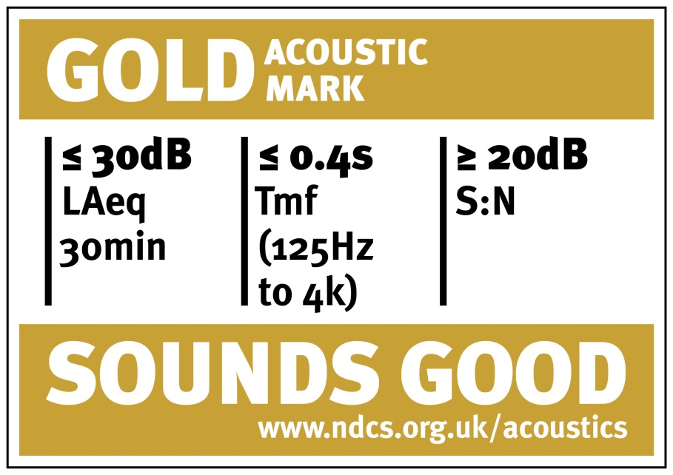

The Gold Quality Mark is the aspirational goal for acoustic conditions and we would strongly encourage schools to meet this standard to support pupils with a hearing impairment.

For a classroom to achieve the Gold Quality Mark, it must have been acoustically tested by a competent acoustic consultant, who has reported the results formally. This will show that the space has surpassed the minimum acoustic conditions, which in England means those required under the Schools Premises Regulations (2012) and Independent School Standard (2013) for teaching spaces.

The Gold Quality Mark can be achieved by meeting all of the following conditions:
- a low background noise level (less that 30dB(A) when unoccupied, over 30 minutes)
- a reverberation time that is less or equal to 0.4 seconds over the extended frequency range of 125Hz to 4kHz and that is less or equal to 0.4 seconds in each octave frequency band (which achieves the aspirational British Association of Teachers of the Deaf ( BATOD) standard).
- the signal to noise ratio (S:N) having a difference of between LA90 and LA50 over 30 minutes of no greater or equal to 20dB, between 750Hz and 4kHz at all points where a child may be located for learning.
- an accessibility strategy should also be available for the space, in accordance with the Equality Act 2010.

Silver Quality Mark

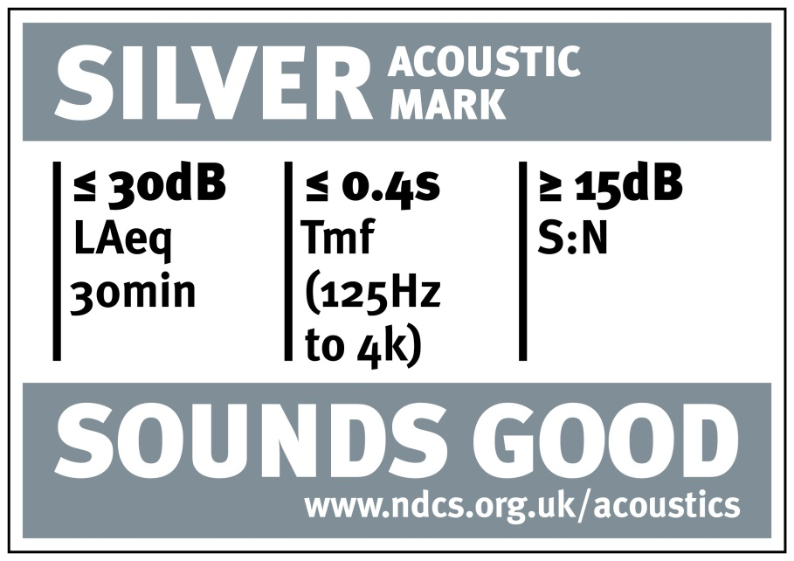

The Silver Quality Mark is the minimum standard that we would expect to be suitable for those with special hearing needs (and which would satisfy the Schools Premises Regulations (2012) in England).

For a classroom to achieve the Silver Quality Mark, it must have been acoustically tested by a competent acoustic consultant, who has reported the results formally.

The Silver Quality Mark can be achieved by meeting all of the following conditions:

- a low background noise level (less that 30dB(A) when unoccupied, over 30 minutes)
- a reverberation time that is less than an arithmetic average of 0.4 seconds over the extended frequency range of 125Hz to 4kHz and that is less or equal to 0.6 seconds in each octave frequency band (which falls short of the aspirational British Association for Teachers of the Deaf (BATOD) standard)
- the signal to noise ratio (S:N) has a difference of between LA90 and LA50 over 30 minutes of no greater or equal to 15dB, between 750Hz and 4kHz at all points where a child may be located for learning
- an accessibility strategy should also be available for the space, in accordance with the Equality Act 2010.

Bronze Quality Mark

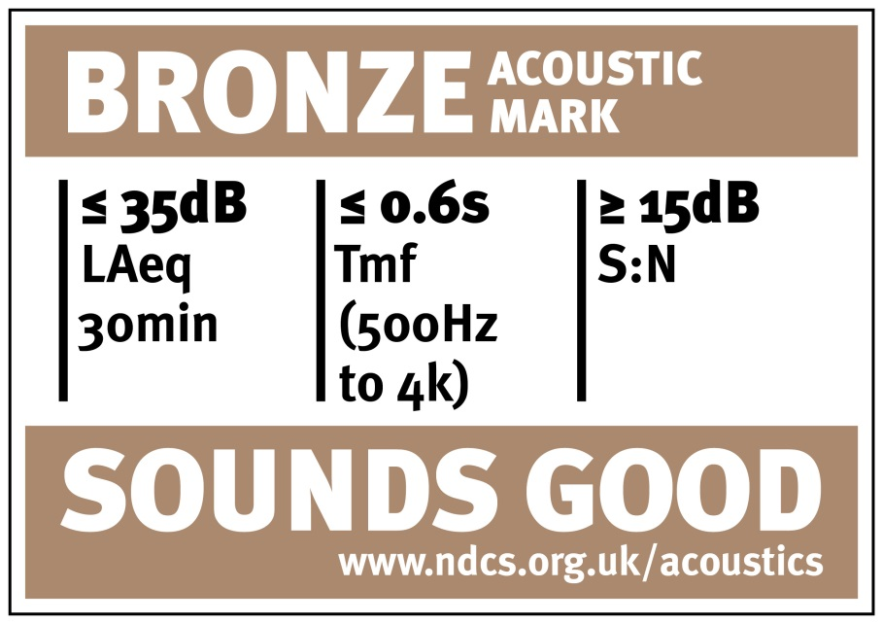

The Bronze Quality Mark would only be considered acceptable if a formal exception has been made with clear justification provided to relax the standards. This minimum acoustic standard is only suitable for use by pupils with a hearing impairment and special listening needs, if there are other measures in place that should be part of the accessibility strategy, such as a separate room that at least meets the Silver Quality Mark.

For a classroom to achieve the Bronze Quality Mark, it must have been acoustically tested by a competent acoustic consultant, who has reported the results formally.

The Bronze Quality Mark can be achieved by meeting all of the following conditions:
- a low background noise level, less that 35dB(A) when unoccupied, over 30 minutes
- a reverberation time that is less than an arithmetic average of 0.6 seconds over the frequency range of 500Hz to 4kHz.
- a record of agreement by an acoustician and school client body, including head teacher and governors) if it is to be used by those with special hearing and communication needs.
- the signal to noise ratio (S:N) has a difference of between LA90 and LA50 over 30 minutes of no greater or equal to 15dB, between 750Hz and 4kHz over an average of the teaching space
- an accessibility strategy is also available for this space, in accordance with the Equality Act 2010.

As well as children with a permanent or temporary hearing impairment, this also includes children with speech, language and communication difficulties; vision impairments; attention deficit hyperactivity disorders (ADHD); an auditory processing disorder or difficulty; or being on the autistic spectrum.
At least a member of the Institute of Acoustics (IOA) (www.ioa.org.uk) or whose company is a member of the Association of Noise Consultants (www.association-of-noise-consultants.co.uk)
That technical performance defined for each quality mark.

