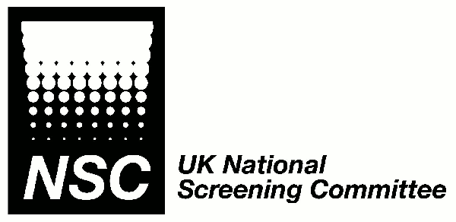
UK National Screening Committee
Newborn screening for cytomegalovirus –an evidence review

Consultation comments pro-forma

Name: | Vicki Kirwin |  |  | Email address: |  | vicki.kirwin@ndcs.org.uk
Organisation (if appropriate): |  |  | National Deaf Children’s Society
Role: | Development Manager (Audiology)
Do you consent to your name being published on the UK NSC website alongside your response?

Yes X No

Section and / or page number |  | Text or issue to which comments relate |  |  | Comment  Please use a new row for each comment and add extra rows as required.

Other comments:

NDCS is the leading charity working with children and young people with all types and levels of deafness, their families, and the professionals who support them. We believe that deaf children can do anything other children do given the right support from the start and offer a range of family support to our members including a Helpline, information leaflets, specialist advice services and a family weekend programme. Through our work with families we know that parents of babies who have been diagnosed with congenital CMV are frequently devastated to know that their child’s hearing loss may have been avoidable.

NDCS welcomes current research in this area into vaccines, screening, and treatments. NDCS firmly believes in informed choice and therefore welcomes research that will hopefully lead to a routine non-invasive test being available giving parents an opportunity to find out whether their baby is at risk of developing deafness and along with their medical team make choices that are best for them and their baby.

Having read the consultation document we understand the UKNSC’s reasons for not recommending screening at this time. We would urge the Committee to consider timely review of the evidence as it becomes available. Thank you for giving us the opportunity to respond at this time.

Please return to the Evidence Team at screening.evidence@nhs.net by Wednesday 13th September 2017.

