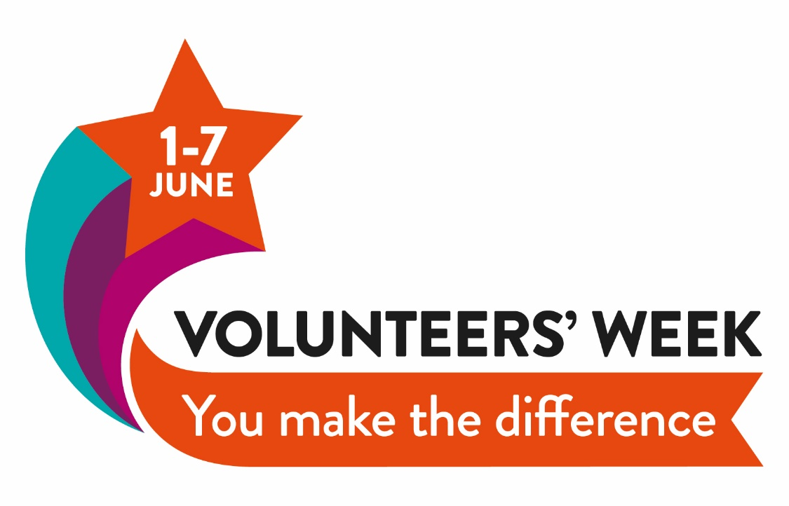

**It’s time for a   
Big Thank You!**

Is there someone on your committee or part of your team who goes that extra mile? Someone whose energy helped launch a new group? Who organises events or helps reach out to local families? Or maybe you know of someone who works quietly behind the scenes to little fanfare?

**Now is your chance to say thank you by nominating them for a Local Groups BIG THANK YOU AWARD!**

To celebrate Volunteers’ Week in June, the National Deaf Children’s Society Local Groups team invite you to nominate your outstanding fellow volunteers for an award. Nominations can be made by anyone, no matter your age or role. **Five winners will receive £100 each to spend on their local group**.

**Complete the form overleaf, or make a video clip using BSL or spoken word and email it to** [**local.groups@ndcs.org.uk**](mailto:local.groups@ndcs.org.uk)**. You can nominate more than one volunteer.**

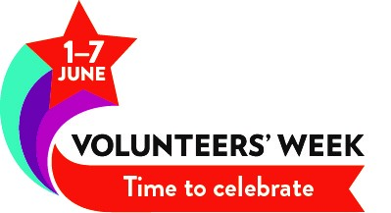

**Nominations close   
30 April 2019**

**My name**:

**My telephone/email**:

(We won’t share these with anyone)

**I would like to nominate**:

**From local group/DCS**:

**I would like to nominate them because**:

a