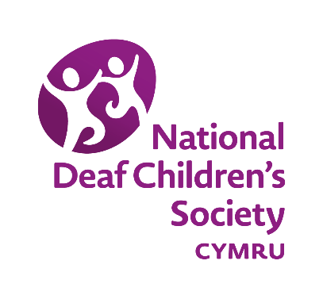
Deaf Children in Wales
Briefing for Parliamentary Candidates
December 2019
Background
As a Wales parliamentary candidate, we wanted to provide a nation specific briefing. Many of the areas the National Deaf Children’s Society campaigns on (aside from Disability Benefits and Equalities Law) are devolved. We’ve highlighted some of the key areas that we’re currently working on below.
Education
The Welsh Government is in the process of a number of significant educational reforms, including a curriculum review and a new system for planning support for those with additional learning needs. We’ve been calling for these changes to take account of deaf learners. This is especially crucial given that Welsh Government statistics demonstrate significant and consistent attainment gaps between deaf learners and their hearing peers (see here).
While some changes have been made to these reforms, we believe much more is needed to ensure that deaf learners are not left behind.
Many young people (both deaf and hearing) are keen to see the introduction of a BSL GCSE in Wales. Qualifications Wales is reluctant to develop a BSL GCSE specifically for Wales because discussions are ongoing to develop one in England. There is, however, a clear willingness for Wales to introduce any BSL GCSE developed in England. So we’ve been keeping a close eye on discussions at Westminster on this!
Early Years
Every child has the right to develop language and communication. The vast majority of deaf children (90%) are born to parents with no previous experience of deafness. It is imperative that these families are supported to communicate with their child.

In Wales, we have been calling for the Welsh Government’s review of opportunities to learn BSL to acknowledge the barriers families face in this regard. We believe support to learn sign should be offered free of charge to families of deaf children who wish to pursue this form of communication.

The Additional Learning Needs and Education Tribunal Wales Act will come into force in September 2021 and will extend education support plans to 0-5 year olds. The National Deaf Children’s Society Cymru is keen to ensure that these plans are effectively implemented for deaf children and their families.

Changes to support services
In recent months, we have seen a number of changes to local support services for deaf children in Wales. The support provided by specialists such as Teachers of the Deaf is crucial in supporting deaf learners to reach their full potential. We are keen to work with MPs to protect this valuable support and influence hearing impaired service restructures within their constituencies.
More information
The National Deaf Children’s Society Cymru campaigns on many more issues, including access to support from social care and health services.
More information can be found here.
Alternatively, please feel free to contact our policy and campaigns team in Wales directly at Campaigns.Wales@ndcs.org.uk.
Thank you.

