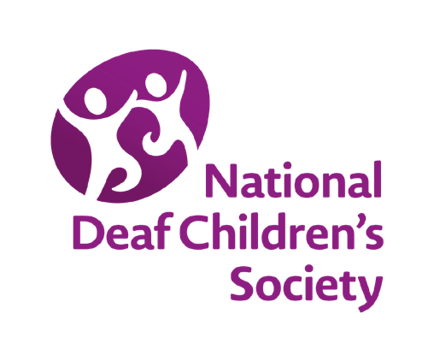
RESOURCE 3.2
MYTHBUSTING ANSWERS

1 | Once I leave school I won’t get any more help or support with my deafness.  FALSE!  Colleges, universities and apprenticeship providers are required by law (Equality Act 2010 or Disability Discrimination Act 1995 in Northern Ireland) to do as much as they can to make changes to how they teach and put support in place for disabled people.  In England and Wales some deaf young people have plans (Education, Health and Care plans in England or Individual Development Plans in Wales), which means they have a right to the support that is written in their plan. Higher education students can apply for Disabled Students Allowances to pay for the cost of things like radio aids, British Sign Language (BSL) interpreters or electronic notetakers.
2 | I won’t be able to go to university because I’ll struggle to hear the teacher during lectures.  FALSE!  Lots of deaf people go to university and there’s lots of support available to help you during lectures or with other aspects of university life. You can apply for Disabled Student’s Allowances which can help you pay for the support you need.
3 | I won’t be able to do the same jobs as my hearing friends because I’m deaf.  FALSE!  Don’t let your deafness hold you back when choosing a career.  With the right support in place deaf people can do lots of jobs!

4 | If I get a job interview I should tell the employer that I’m deaf before the interview.  TRUE!  You should never feel worried about telling employers that you’re deaf. The Equality Act 2010 and the Disability Discrimination Act 1995 (Northern Ireland only) make sure employers can’t discriminate against people with a disability. So you shouldn’t feel worried about the interview being cancelled or the employer not offering you the job because you’re deaf.  If you mentioned that you’re deaf on a job application or before an interview then the employer can make sure that the right support is available during the interview, for example a BSL/Irish Sign Language (ISL) interpreter, a palantypist or even just a room with good acoustics. If you get the right support for the interview then you’re more likely to do well during the interview and you’ll have a better chance of getting the job!  So this is very important. It is however still a personal choice and up to you if you tell your employer at interview.
5 | I won’t be able to get a job in an office because I’ll find it too difficult to take part in discussions during meetings.  FALSE!  Your employer will have to put reasonable adjustments in place to support you in meetings, eg make colleagues aware that they should speak one at a time during meetings, schedule meetings far enough in advance to allow you to arrange communication support etc.  You could also apply for the Access to Work (AtW) scheme and use the funding to pay for the communication support or technology you need to allow you to access communication. For example, you could use the funding to pay for a BSL interpreter or palantypist to support you in meetings. Or you could purchase a radio aid to help you in meetings.  You will have to make the application to AtW yourself but your employer should fully support you in this.

6 | When I have a job and I want to use Access to Work funding, my employer will sort this out for me.  FALSE!  Your employer should support you with your AtW application and provide any documents you may need but the only person responsible for making sure you get AtW funding is you!  It’s not always easy to get the full amount of support – it helps to be well prepared for the assessment process and to prepare good reasons for why you need the AtW funding and how it will support you in the workplace.
7 | If my employer has paid for reasonable adjustments at work then they can pay me a lower salary.  FALSE!  Under the Equality Act 2010 and the Disability Discrimination Act 1995 (Northern Ireland only) your employer has to pay for reasonable adjustments in the workplace. They can never ask you to pay, or offer you a lower salary.  Some examples of reasonable adjustments which your employer would have to pay for are: a visual fire alarm at work, a phone amplifier or appropriate headset, a smartphone provided by work, deaf awareness training for colleagues etc.
8 | Deaf people can fly aeroplanes.  TRUE!  Deaf people can learn how to fly an aeroplane. However, a licence to be a commercial aeroplane pilot wouldn’t be granted to someone who can’t  hear messages from air traffic control. Deaf people can still fly aeroplanes which don’t come under air traffic control. Have a look at this website if you want to learn more about this:  www.deafpilots.co.uk

9 | Some deaf people are able to get a job in the Army or as a police officer.  TRUE!  A medical is required for all job roles and a certain threshold of hearing is needed. Someone with unilateral or mild deafness may pass this and cases are assessed on an individual basis.
10 | Some deaf people can’t work on seafaring ships, for example on cruise ships.  TRUE!  Some deaf people are still not allowed to work on any seafaring ships, this incudes working on a cruise ship. This is because anyone working on a boat is required to obtain a seafarer’s medical certificate. As part of this there  is a test of hearing ability with the expectation you can understand speech through a radio or tannoy system.

