# ADNODD 5.1 CYLCHOEDD

**PROFIAD  
GWAITH**

CRYFDERAU, DIDDORDEBAU, PERSONOLIAETH

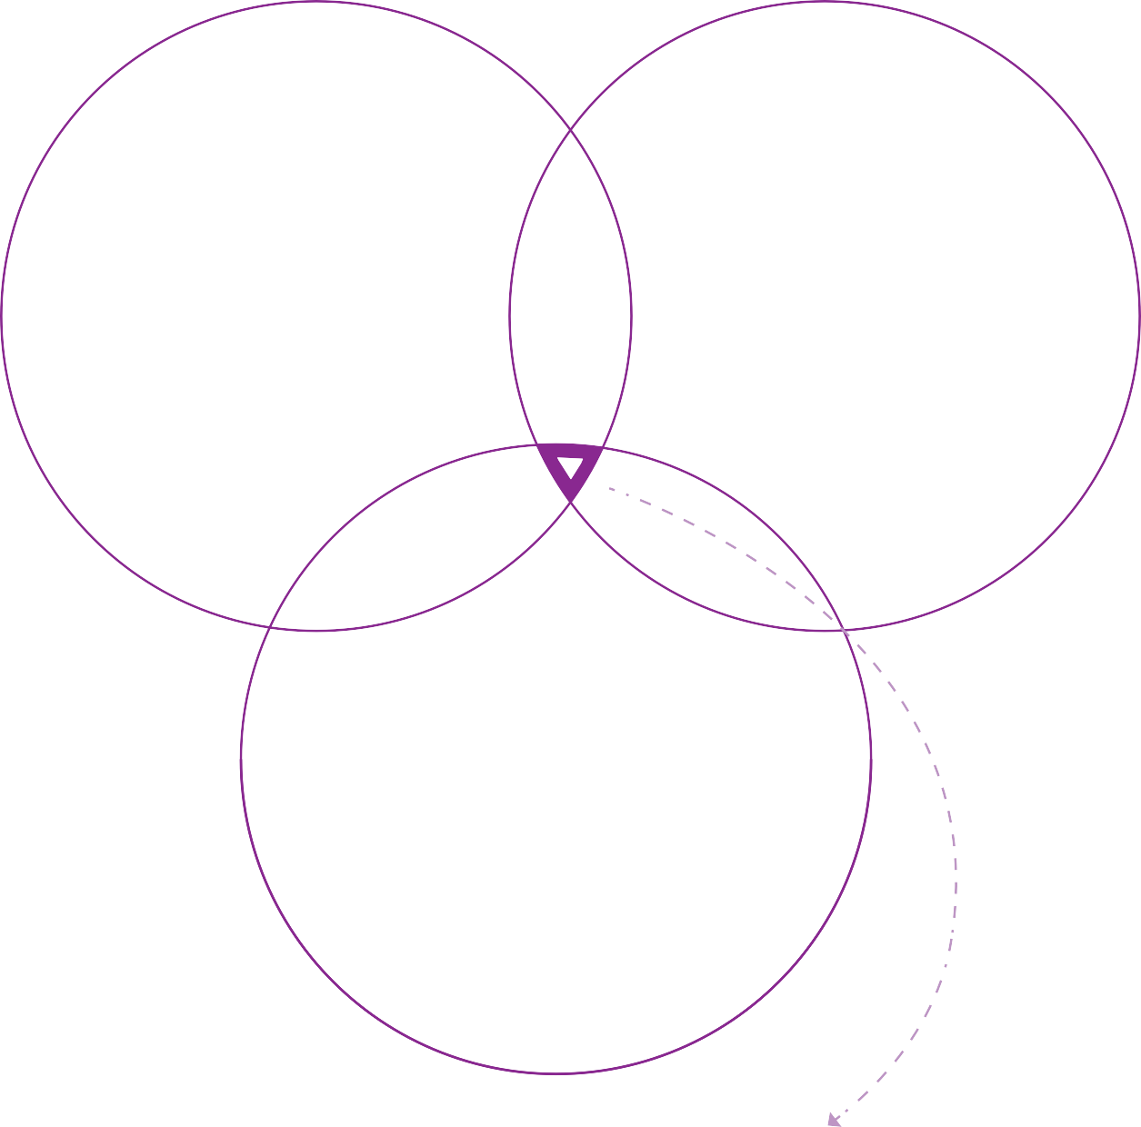

**PROFIAD  
GWIRFODDOLI**

Click here to enter text.