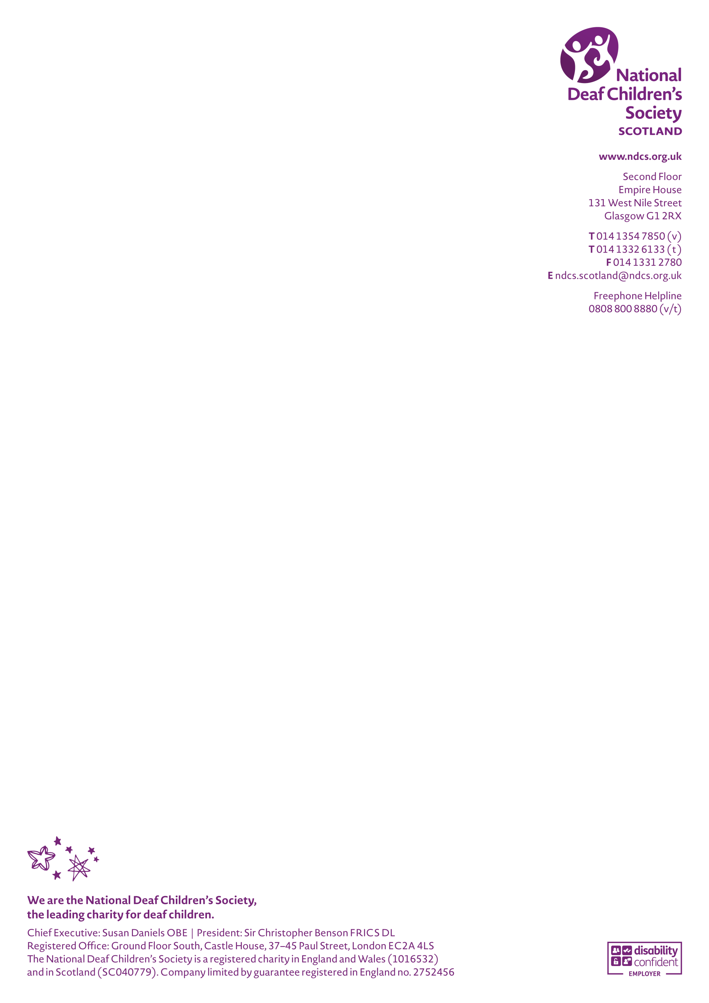
Petition PE1867: Establish a new national qualification for
British Sign Language (BSL)
Response by National Deaf Children’s Society
June 2022

- Introduction
The National Deaf Children’s Society (NDCS) is the leading charity in Scotland dedicated to creating a world without barriers for deaf children and young people.
Our response to this petition has been informed by consultation we have undertaken as part of our role on the British Sign Language Partnership with both deaf young people and parents of deaf young people.
NDCS uses the term “deaf” to refer to all types and levels of hearing loss.
- There are at least 3647 deaf children and young people in Scotland (CRIDE 2019)
- More than 90% of deaf children have hearing parents or carers, this makes support, intervention and information in the early years crucial for families, to ensure children have the best start in life;
- Around 87% of deaf children are educated in mainstream schools, making additional specialist support crucial to ensuring these learners reach their full potential;
- The specialist teacher workforce continues to face challenges with data suggesting overall reductions in numbers of Teachers of the Deaf in education authorities
- With the right support, deaf young people can achieve as much as their hearing peers. However we continue to be concerned about the persisting education attainment gap facing deaf young people.

- Background
The passage of the British Sign Language (Scotland) Act 2015 marked a historic moment for deaf people across Scotland. While not all deaf children use BSL, and not all BSL users are deaf, we recognise the importance of BSL in deaf culture, and share the aspiration as set out in the Scottish Government BSL plan 2017-2022 that Scotland should be the best place in the world for BSL users to live, work and visit. A country where public bodies routinely use and promote BSL, as required by the Act, will by definition be a more deaf-friendly country for children to grown up in.
With over 90% of deaf children being born to hearing parents, it is crucial that families receive timely interventions of support and information and the opportunity to learn BSL to communicate with their child. The availability of age-appropriate sign language classes for parents of deaf children is also important in terms of promotion of the language. Even where families have good access to information on BSL, they may not always have genuine informed choice. The decisions some families make with regards to how they communicate with their child may be influenced by the reality of provision in their local area. For example, the lack of opportunities to learn and be supported in school using BSL may discourage families from pursuing BSL as a communication method.
Deafness is not a learning disability and with the right support, there is no reason why deaf young people overall should be achieving any less than their hearing peers. However Scottish Government data shows that there is a wide attainment gap for hearing impaired school leavers, and the attainment of this group is among the lowest of all pupils in Scotland.

The latest Scottish Government data shows that deaf learners were over 2 times more likely to leave school with no qualification (5.7% of deaf learners left school with no qualification compared with 2.4% of all pupils) and 48.6% obtained Highers or Advanced Highers (compared with 62.9% of all pupils). This gap in achievement at school goes on to affect deaf young people’s life chances, with 30.5% of deaf learners going on to university compared with 54.4% of those with no additional support need (ASN).

Therefore the issues raised in this petition about opportunities for the academic study of BSL are crucial in ensuring that deaf children and their parents can chose the options they want and feel most appropriate for their education
- The petition
The Petition highlights that because there are no National Qualifications (i.e. Nat 5/Higher/Advanced Highers) available for BSL, it cannot be taught as an "L2" language, but only as a "L3" language. This limits the uptake and usefulness of learning BSL in primary school in Scotland, since there can be no progression to learning BSL in the senior phase and an L3 language can only be taught from P5 (as opposed to P1 for an L2) .
The National Deaf Children’s Society shares this concern, and believes that as one of Scotland’s four indigenous languages, with its own rich culture and tradition, BSL should be widely taught in the Broad General Education phase, and an option for as many children as possible in the senior phase. Just as we have welcomed moves to increase the teaching and learning of Gaelic in Scottish Schools, our hope is that BSL, is in future, afforded similar status and support,
- Commentary on responses the petition – Scottish government
The Scottish Government, in its letter to the committee of 14th March 2021 stated
The Scottish Government share the petitioner’s vision for BSL to become more widely taught in schools. As part of the Scottish Government’s work to drive forward implementation of the 1+2 policy, we are working with Education Scotland, Scotland National Centre for Languages and other partners to promote BSL in schools and develop support material for teachers.
We welcome that commitment, and the commitment to promote BSL and develop support materials. The letter from the Scottish Government then goes on to note the substantial increase in the number of primary schools providing BSL as an L3 language, which again we welcome.
However, the Scottish Government then argues that simply making BSL available as a national qualification will not necessarily lead to the language being offered as an L2 by schools, emphasising that it remains the choice of schools to decide which language to teach. While this is true, and we recognise that even with a national qualification not all schools will choose to teach BSL, without a National Qualification in place that choice for schools is simply not available.
We would therefore argue that if the growth in schools offering BSL within 1+2 language provision is to continue, and the stated aspirations of the Scottish Government for BSL to become more widely taught in schools is to be realised, schools need to have the option to teach BSL as an L2 language, not just a L3 language.
Such an approach, would help lead to BSL to become more widely taught in schools is also in line with Theme 2 of “Support for learning – All our Children and All their Potential”, the independence review of the Additional Support for Learning which focusses on the mainstreaming and inclusion of children with additional support needs. The review highlighted the four principles of the Scottish Government guidance on inclusion of children with additional support needs in mainstream schools, which are present, participating, achieving and supported. Together these four principles should support the delivery of inclusive learning environments for all children and young people that enable them to reach their full potential.
The review report however highlights that many children with additional support needs actually, often feel isolated and uncared for at school. For deaf children in mainstream schools, the inability of a school to teach BSL from P1 as a L2 language can leave them unable to communicate with their hearing friends, and make them feel that their deaf identity is not respected in the school. Making it possible for schools to teach BSL within the curriculum from P1, especially where there is a BSL-using student or student in the school is therefore crucial to inclusive education.
- Commentary on responses the petition – SQA
The SQA makes a number of similar points in its letters of the 30th November 2021 and 4th March 2022.
It cited two main barriers to National qualifications in BSL
1. Evidence of demand for a National Course from language learners and delivering centres.
2. Sufficient qualified and registered teachers to develop, deliver and assess the National Course.
In terms of the first point, the SQA clarified that their belief that there is currently not enough evidence of demand from learners for a National Qualification on an assessment of the demand within schools for the BSL award qualifications they do offer.
However, the qualifications that the SQA are referring to are of a different character to the ones that are being sought by the petition author. The SQA BSL Awards are aimed at BSL users and BSL learners of any age, and can not be used for college or university entrance.
As the Scottish Government themselves pointed out, the very substantial increase in interest in schools in teaching BSL as an L3 demonstrates the level of interest. The 113 primary schools who are teaching BSL at L3 (138) is greater than the 38 primary schools offering German 38 (at L2 or L3) and comparable with the 153 offering Mandarin (at L2 or L3). National qualifications are available in both these languages.
Research carried out by the Youth Advisory Board of the National Deaf Children’s Society found that 92% of young people in Scotland surveyed wanted to learn more BSL. Thanks to the coverage of BSL users like Rose Ayling-Ellis, the first deaf contestant on Strictly Come Dancing, there has been a recent surge in young people starting to learn British Sign Language, which cannot currently be met in school. We recognise that there is a significant challenge around the second issue highlighted by the SQA, the low number of qualified and registered teachers of BSL. We therefore welcomed the commitments made in the BSL National Plan 2017-23 to work with the General Teaching Council for Scotland (GTCS) to remove barriers that make it difficult for BSL users to become registered teachers (Action No. 16). We welcome the work by the University of Edinburgh to develop a new undergraduate degree in MA Primary Education and British Sign Language, which would lead to teachers qualifying as primary school teachers with enhanced skills in BSL. However, if we are to see National Qualification in BSL there will also need to be a supply of suitably qualified and registered teachers of BSL for the senior phase.
However, we feel that citing the lack of supply of availability of suitability qualified teachers as a reason to not develop the courses that would demand these teaching skills is a chicken and egg situation. If schools do not have the option of offering a national qualification, then we are unlikely to ever see sufficient teachers choose to develop their skills in teaching BSL. In England the shortage of people who could currently teach the proposed BSL GCSE has not in practice acted as an obstacle in the development of the GCSE and discussions are now taking place about a professional development programme to increase the numbers of suitably qualified and registered teachers of BSL to an appropriate level.
The SQA also state that there are particular difficulties in teaching BSL in an academic context as a language rather than as a communication tool. They highlight that while other Modern Languages teaching develop four skills (reading, writing, speaking and talking), while BSL involves two modes (receiving and giving). They therefore argue that “the approach to assessment needs to be unique to BSL and it does not lend itself to our traditional examination approach”. However, good progress is being made in both England and Wales in developing GCSES in BSL, and we suggest that the SQA could collaborate or learn from work being undertaken in these countries to address similar challenges.
Finally, the SQA cite a lack of clarity over Leadership as a barrier. We would agree with this, and believe that the fundamental barrier to the development and teaching of National qualifications is not about levels of demand, numbers of teachers or the particular challenges of teaching and assessing BSL, but in a lack of clarity about the level of commitment to BSL as one of Scotland’s indigenous languages.
We would highlight the contrast with Gaelic, where a high level of political commitment has led to the development of an effective language plan for the promotion and development of the teaching and learning of Gaelic. We would hope in future to see similar levels of commitment BSL as has recently been given to Gaelic, which would enable the Scottish government to deliver its stated commitment to BSL.
6 Next steps
Although progress has been made in a number of areas, the progress outlined in the recent report on the delivery of the Scottish BSL action plan indicates how much more still needs to be done.
We are aware that work is currently underway to develop the next six year BSL plan, as the 2017-2022 plan comes to an end.
As part of this work we would ask that the committee writes to the Cabinet Secretary for Education to request that specific work is carried out as part of the development of the BSL Plan to look at how BSL national qualifications could be developed, drawing on similar work being undertaken in other UK nations where necessary.
We would further suggest that the committee request that Cabinet Secretary then reports back to the Public Petitions and Citizen Participation Committee on the steps that will be taken to ensure that schools have the opportunity to teach BSL from P1 to Highers and Advanced Highers.

For more information, please contact Mark Ballard, Head of Policy and Influencing for Scotland, National Deaf Children’s Society mark.ballard@ndcs.org.uk

See https://www.ndcs.org.uk/media/6965/cride-2019-scotland-report-final.pdf
See https://www.gov.scot/publications/british-sign-language-bsl-national-plan-2017-2023/
Full data sets can be found here: Summary Statistics for Attainment and Initial Leaver Destinations, No. 4: 2022 Edition - gov.scot (www.gov.scot)
See https://www.parliament.scot/-/media/files/committees/citizen-participation-and-public-petitions-committee/correspondence/2022/pe1867/pe1867_d.pdf
https://www.parliament.scot/chamber-and-committees/committees/current-and-previous-committees/session-6-citizen-participation-and-public-petitions-committee/correspondence/2021/pe1867_b-scottish-qualifications-authority-submission-of-30-november-2021
https://www.parliament.scot/-/media/files/committees/citizen-participation-and-public-petitions-committee/correspondence/2022/pe1867/pe1867_c.pdf
https://www.gov.scot/publications/12-languages-policy-findings-2021-survey-local-authorities/pages/3/
S:\Policy and Campaigns\Campaigns\Education\Right to Sign BSL campaign\Report\JR1219 Right To Sign Report AW WEB.pdf

