
…………………………………’s personal passport
I am …………. years old.
I am OK for this profile to be shared with:

If you aren’t sure about anything, please ask me and my caregiver first. Our contact details are:

About my deafness
- My hearing loss level in my left ear is:
- My hearing loss level in my right ear is:

I like to communicate through…
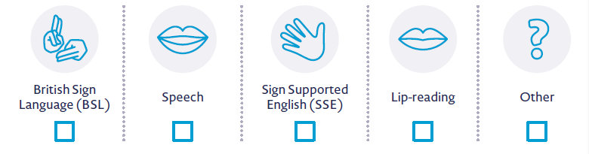
☐ ☐ ☐ ☐ ☐

The technology I use is…
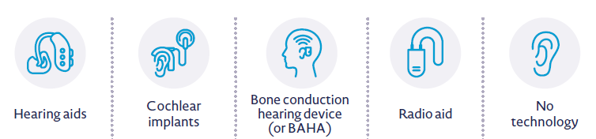
☐ ☐ ☐ ☐ ☐

Notes from me and my parent or carer
My deafness
Do doctors say that I have mild, moderate, severe or profound hearing loss? Are one or both of my ears affected? How does my deafness affect my daily life? (For example, can I hear someone speaking in a noisy room?)

My communication preferences
How do I like to communicate with other people? Do I sign, use speech or a mixture of both? Are there any specific non-verbal signs or gestures that I use a lot?

The technology I use
Remember: Always keep hearing devices dry!
What kind of technology do I use? Where are the spare batteries kept, and who can change them? Do I feel confident about my hearing technology? If I use a radio aid, how does it work, and where is it kept? Can my technology be worn around water? If I’m having a problem with my technology, how would I like to be helped – even if I don’t feel confident enough to ask in front of a group?

Find out more about assistive technology at ndcs.org.uk/information-and-support/assistive-technology/.

How you – and others – can support me
What can others do to support me? Do I need extra breaks? Would visual cues help me understand instructions? Do I need to see other people’s faces when they speak?

Watch five tips that help hearing peers communicate, support and include their deaf peers: ndcs.org.uk/get-involved/become-more-deaf-aware/early-years-deaf-awareness-videos/.

Things I find challenging
What are the signs that I haven’t heard or fully understood? (These could be things like not completing tasks, acting worried or frustrated, or changes in my behaviour.) How can others support me with this?

When I haven’t heard something
Are there any specific things that I find particularly difficult? (These could be things like loud environments, wearing hearing technology, or travelling to and from school or nursery.) How can others support me with this?

Other information (and maybe even some art from me!)
This is a space for me to include anything else I (or my grown-ups) think you should know. If I feel up to it, I might even draw some pictures or share about my favourite things (like my favourite colour, food, animal, TV show, sport, movie, game, hobby, book, place or person)!

Health and safety: Important things to consider
☐ I struggle to hear fire alarms or other announcements. Please check I’ve noticed them!
☐ I need easy-to-understand, written versions of any health and safety information.
☐ If my sources of communication support aren’t around, the backup communication method I’m most comfortable with is ……………………………………………………………………….
☐ If you’re dealing with sensitive topics (like self-care), please make sure you’ve thought about how that would translate in my preferred communication method(s).
☐ If you notice I’m feeling isolated or struggling socially, please help me by …………………….

