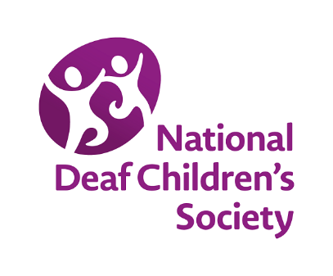

**Deaf-friendly teaching: For children who use English as an additional language (EAL)**

### **Child information form template**

## Medical/clinical history

|  |  |  |  |
| --- | --- | --- | --- |
| **Information about deafness** | | | |
| Level and description of deafness | Cause(s) of deafness (if known) | | |
| Date and location of last hearing assessment | Audiogram attached | Yes | No |
| Date and location of diagnosis | Date and location of technology fitting (if applicable) | | |
| **Technology used (type and model)** | | | |
| What technology has been used in the past?  What technology is being used now?  How is it being used?  Is it appropriate for the child and their family? |  | | |

|  |  |
| --- | --- |
| **Audiological care information** | |
| Who is involved in the child’s audiological care? For example:   * Audiologist * Ear, nose and throat(ENT) specialist * Cochlear implant centre * Speech and language therapist (SLT) |  |
| **Health checks** | |
| Does the family have a GP?  Is the family being seen by a health visitor?  Has the child’s vision been checked? When?  Has the child been offered genetic testing in relation to their deafness?  Has the child ever been seen by a paediatrician? |  |
| **Additional needs** | |
| What other additional needs does the child have?  Whose care are they under?  Do they take medication? |  |

## Education details

|  |  |  |  |
| --- | --- | --- | --- |
| **Previous education (both in the UK and abroad)** | | | |
| Previous school/setting | | Child’s age when they moved from previous school/setting | |
| **Level or stage of education** | | | |
| Assessment or exam information | | Record of learning or work completed | |
| **Level of spoken language** | | | |
| Child’s home language: | | | |
| Information from family | Information from assessment | | Used where and when |
| English (or Welsh) | | | |
| Information from family | Information from assessment | | Used where and when |
| Other spoken languages used (if any): | | | |
| Information from family | Information from assessment | | Used where and when |

|  |  |  |
| --- | --- | --- |
| **Level of sign language** | | |
| British Sign Language (BSL) or Irish Sign Language (ISL) | | |
| Information from family | Information from assessment | Used where and when |
| Other sign languages used (if any): | | |
| Information from family | Information from assessment | Used where and when |
| **Level of reading and writing** | | |
| Child’s home language: | | |
| Information from family | Information from assessment | Used where and when |
| English (or Welsh) | | |
| Information from family | Information from assessment | Used where and when |
| Other languages used (if any): | | |
| Information from family | Information from assessment | Used where and when |

|  |  |  |  |
| --- | --- | --- | --- |
| **Other education or language learning opportunities** | | | |
| For example:   * Community classes * Deaf group * Faith groups | |  | |
| **Previous support received in school or setting** | | | |
| Speech therapy | Occupational therapy | Physical therapy | Vision support |
| Evaluations/assessments | | | |
| Reports available | | | |
| Other information | | | |

## Other considerations

Note: These are not intended as direct questions to ask the family, but the information can be gathered when meeting with them.

|  |  |
| --- | --- |
| **Family’s language use** | |
| Parent’s confidence using spoken English (or Welsh) |  |
| Parent’s confidence to read and write in English (or Welsh) |  |
| Parent’s confidence to read and write in their home language |  |
| Siblings’ confidence using spoken English (or Welsh) |  |
| Other languages used by the family |  |
| Interpreter/translation support |  |
| **Family’s support network** | |
| Who is their support network?  Are they within the local community? |  |

|  |  |
| --- | --- |
| **Parent and child’s understanding of their local education system** | |
| Admissions  Assessment and exams  Attendance  Homework  How to access extra resources and support for their child including needs assessments and free school meals |  |
| Parent and child’s understanding and access to support services including hospital, clinical and education | |
| Are the parents refugees or asylum seekers or included in a resettlement programme? | |
| Attitudes and cultural beliefs about deafness | |