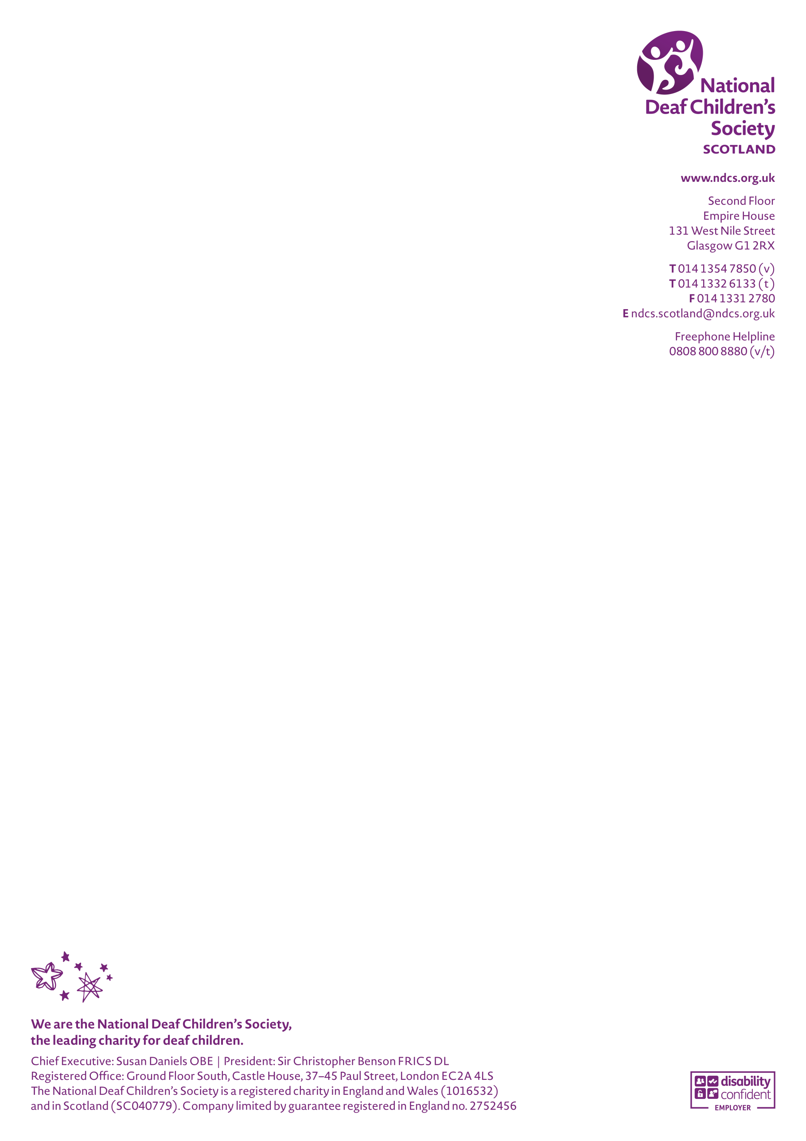
Scottish Government attainment and leavers’ destinations data
National Deaf Children’s Society briefing
2024

Scotland context

- There are at least 3418 deaf children and young people in Scotland (CRIDE 2023)
- 90% of deaf children have hearing parents or carers, this makes support, intervention and information in the early years crucial for families, to ensure children have the best start in life;
- Around 83% of deaf children are educated in mainstream schools, making additional specialist support crucial to ensuring these learners reach their full potential;
- The specialist teacher workforce continues to face challenges with data suggesting a 37% reduction in numbers of Teachers of the Deaf in education authorities since 2011;
- With the right support, deaf young people can achieve as much as their hearing peers. However we continue to be concerned about the persisting education attainment gap facing deaf young people.

Summary of Scottish Govermnent annual data

- The data published in 2024 for the the 2022/23 cohort of school leavers illustrates that a significant attainment gap continues to exist for deaf learners;
- Figures show deaf learners were nearly 3 times more likely to leave school with no qualification, with 7.2% of deaf learners leaving school with no qualification (compared with 2.6% of all pupils) and 43.3% obtaining Highers or Advanced Highers (compared with 57.1% of all pupils).
- The gap continues post-school with 30.1% of deaf learners going on to university compared with 50% of those with no additional support need (ASN).
- We are concerned that the number of deaf young people obtaining no qualification (7.2%) continues, increasing slightly from previous year’s cohort (6.3%).
- There is still a significant gap (13.8%) in numbers of deaf pupils obtaining Highers and Advanced Highers compared with all pupils, however this gap has closed slightly since last year (16.1%).
- There continues to be a gap in numbers of deaf pupils entering HE settings compared to pupils with no ASN (19.9%).
- College continues to be the most popular destination for this group with double the number of deaf pupils entering FE settings (40%) compared with those with no ASN (20.3%).
- The number of deaf leavers entering employment is roughtly consistent with last year’s cohort (15%). This year 15.9% of deaf leavers entered employement compared with 24.6% of those with no ASN.

Full data sets can be found here: https://www.gov.scot/binaries/content/documents/govscot/publications/statistics/2024/02/summary-statistics-attainment-initial-leaver-destinations-no-6-2024-edition/documents/supplementary-tables/supplementary-tables/govscot%3Adocument/supplementary-tables.xlsx

